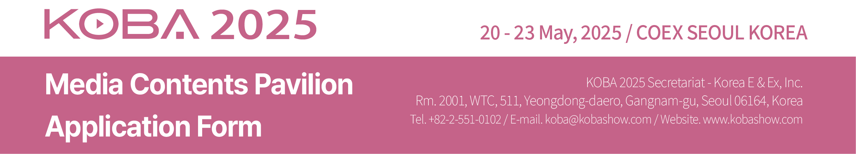

1. Applicant Manufacturer □ Importer □
Company Name
Company  Details | Address
Company  Details | Country |  |  | Tel
Company  Details | Website |  |  | Fax
Contact | Name |  |  | E-mail
Contact | Dept. |  |  | Position
Main Exhibits
□ Please contact our Korean agent / representative for further communication.
Agent Name |  |  |  | Tel.
Contact Person |  |  |  | E-mail

2. Type of Booth
□ Type #1 | 2m x 2m = 4 sqm | USD 1,600 X ________ Booth(s) = USD __________________
□ Type #2 | 3m x 2m = 6 sqm | USD 2,400 X ________ Booth(s) = USD __________________

3. Booths Configuration
□ Single-row Booths □ Double-row Booths (for more than four)
□ Other type Booths (please contact Secretariat Office)
4. Payment Options
□ Cheques / Bank drafts should be made to: Korea E & Ex Inc.
□ Telegraphic transfer can be made to: Bank: Woori Bank
Branch : Korea World Trade Center
Account No. : 1081-500-336520
SWIFT Code : HVBKKRSE
Account Holder : Korea E & Ex Inc.
Bank Address : 511, Yeongdong-daero, Seoul, Korea

We hereby apply for exhibit space at the KOBA 2025 Media Contents Pavilion. We agree to abide by the Rules and Regulations of Participation stated on the reserve side of this application form.

Authorized Person _____________________ Title ________________________

Signature _____________________ Date _______________________

